Team Members:

BALAJI.P (Team Leader)

AKILAN.A

DINESH.S

ARUN.R

Project Title:

Fire Alarm using Industries

Circuit Diagram:

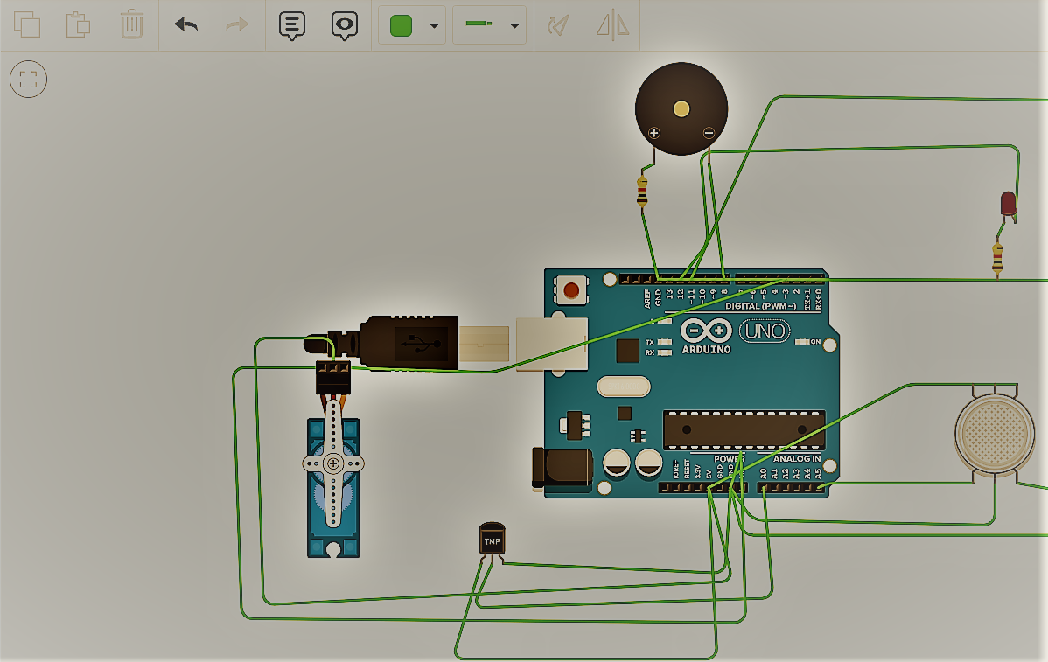

Code:

#include<Servo.h>

int red_led=12;//indicates gas

int blue_led=11;//indicates normal

int buzz=8;//indicates gas

int smoke = A5;

int temp=A0;//indicates sensor connected A5

int sensorThres=40;

Servo s;

void setup()

{

pinMode(red_led,OUTPUT);//red output

pinMode(buzz,OUTPUT);// buzz output

pinMode(blue_led,OUTPUT);//blue output

pinMode(smoke,INPUT);

pinMode(temp,INPUT);

s.attach(3);

Serial.begin(9600);

}

void loop()

{

int a=analogRead(smoke);

int b=map(a,0,1023,0,255);

Serial.println(b);

double c=analogRead(temp);

double d=(((c/1024)*5)-0.5)*100;

Serial.println(d);//reads sensor value

if (b > sensorThres or d>100)

{

digitalWrite(red_led, HIGH);

digitalWrite(blue_led, LOW);

digitalWrite( buzz, HIGH);

for(int i=0;i<=90;i++)

{

s.write(i);

delay(1);

}//turn on buzzer

}

else

{

digitalWrite(red_led, LOW);

digitalWrite(blue_led, HIGH);

digitalWrite( buzz, LOW);

for(int i=90;i>=0;i--)

{

s.write(i);

delay(1);

}///turns buzzer off

}

delay(100);

}